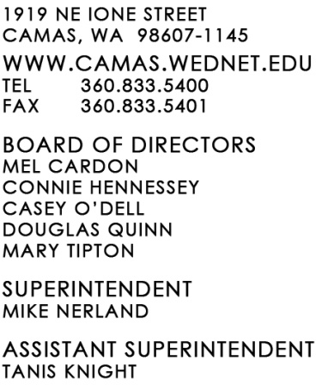
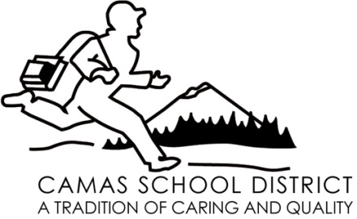

December 1, 2008

For additional information, contact:
Greg Henion, Band Director
Camas School District
(360)833-5850 ext. 7477

FOR IMMEDIATE RELEASE

Camas middle school musicians selected for All-State

Three outstanding eighth grade music students from Liberty Middle School have received top honors by being selected to participate in the fourth annual Washington Music Educators Association (WMEA) Junior All-State West band and choir. Max Whittle, baritone saxophone; Micah Wise, trombone and Rachel Trautman, alto voice; will join more than 200 other outstanding young performers at this gala event. The WMEA Junior All-State groups will meet March 14, rehearse together under the direction of outstanding music educators, and present a final concert that afternoon at the Highline Performing Arts Center in Burien, Wash. These musicians were selected through auditions that were digitally recorded and sent in via the internet. The event is sponsored by the Washington Music Educators Association.

Many professional musicians credit their All-State experience as crucial in their decision to choose music as a career. Thousands of others whose career paths took them in other directions have great memories of participating in this inspiring and motivating musical experience and claim that it was a life-changing experience for them. “The recording process itself was a learning experience for all of the students that auditioned. For the three that were selected, the experience of rehearsing and performing with some of the best young musicians in the state will be truly unforgettable!” said Greg Henion, Liberty band director.

Well-known Washingtonians who have participated in past years’ WMEA All-State groups include: The Seattle Post-Intelligencer's Pulitzer Prize-winning editorial cartoonist and columnist David Horsey, 2008 National teacher of the Year Andrea Peterson, former Spokane County Sheriff Mark Sterk, and saxophonist Kenny G.

--end--

